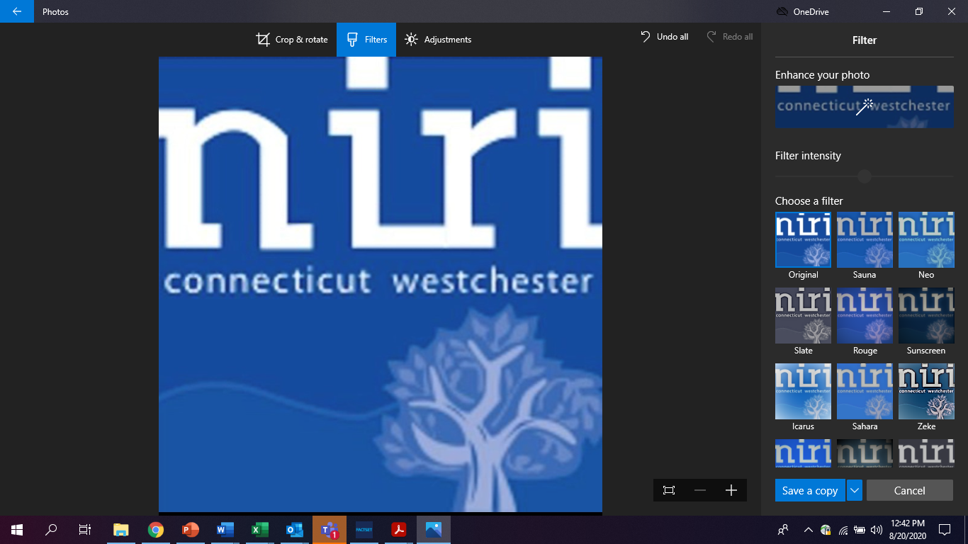

September 16, 2020

**Via Email: rule-comments@sec.gov**

Ms. Vanessa Countryman  
Secretary  
U.S. Securities and Exchange Commission

100 F Street, NE  
Washington, DC 20549

**Re:** **Reporting Threshold for Institutional Investment Managers, Release No. 34-89290; File No. S7-08-20**

Dear Ms. Countryman:

The undersigned individuals, who are part of the leadership of the National Investor Relations Institute (NIRI) Connecticut/Westchester County Chapter, are writing, on behalf of the chapter, to express opposition to the Commission’s proposed amendments to the 13F disclosure rules.

We represent members who are investor relations officers of public companies headquartered in Connecticut and Westchester County, New York. These companies, listed on the New York Stock Exchange and the Nasdaq, have a combined market capitalization of over $500 billion. We also represent investor relations counselors who advise other public companies across the country and in other countries, including counselors that provide stock surveillance and shareholder targeting analysis.

We urge the Commission to withdraw this proposal and instead consider the reforms that were detailed in rulemaking petitions submitted by our parent organization, the National Investor Relations Institute (NIRI), NYSE, Nasdaq, and other organizations.[1] Rather than allow 4,500 current 13F filers to go dark, we urge the Commission to reduce the archaic 45-day reporting period, require 13F filers to disclose short positions, and support legislation to provide for monthly disclosure.

While we agree that the SEC should modernize its ownership reporting rules, our members believe that the proposed 35-times increase in the 13F threshold would deprive companies and investor relations professionals the transparency of valuable information that they need for effective issuer-investor engagement and to prepare for potential shareholder activism.

As part of the investor relations responsibility for effective issuer-investor engagement, one of the most important duties of our members is to advise their C-suite executives on whether to accept a meeting or call request from an institutional investor, and to ascertain the investor’s motive for requesting that meeting. Our members must assess whether the investor is legitimately interested in initiating or maintaining an investment or has an ulterior motive such as shorting the stock, proposing management change or learning competitive information enabling the investor to invest in another related company.

A key consideration in advising C-Suite executives is the knowledge that the investor actually holds the company’s shares, the size of that position, whether the investor is increasing or decreasing that position, and whether the investor has a track record of activism. To make these determinations, most U.S. issuers rely heavily on the quarterly ownership information in 13F filings, the only accurate source available. [2] While some of this information is out of date by the time companies receive it, given the 45-day time lag, this data is nevertheless critical for companies when they decide how to prioritize investor requests for engagement. [3]

As an example of the critical importance of this information and the negative consequences of the proposed threshold change, one of our chapter members is an Investor Relations director for a publicly traded company in the business services sector with a market capitalization of approximately $1 billion. Based on the 13F filings from June 30, 2020, this member’s firm would see a decrease of 38% in its number of filers. Additionally, there would be a decrease of 40% in active filers, which creates a large barrier between the company’s leadership team and investment community, making it difficult to address key investor concerns and/or maintain communication between both parties.

In another example, an Investor Relations consultant in our chapter represents a microcap steel company headquartered in Pennsylvania that would see a 35% decrease in the number of its 13F filers, including a 44% decrease in its top 25 holders that would be required to file, based on June 30, 2020 13F filings.

As one might expect, small and mid-cap issuers typically have a greater percentage of mid and small sized institutional investors which would be exempt from reporting under the proposed rule. As a result, small and midcap issuers would be especially hard hit by this loss of transparency.[4] As Commissioner Allison Herren Lee pointed out in her dissenting statement, many smaller companies cannot afford to hire a stock surveillance firm or take other measures to attempt to offset the loss of 13F data, and thus would lose visibility into a significant percentage of their investors.[5] This may discourage private small and midcap issuers from seeking access to public markets in initial public offerings.

For the foregoing reasons, we urge the Commission not to adopt the proposed 35-times increase in the 13F reporting threshold and instead implement the reforms proposed by NIRI and other organizations to improve market transparency and foster more effective issuer-investor engagement.

Signed,

NIRI Connecticut/Westchester County Chapter

June M. Vecellio-Lazaroff James B. Bragg

June Vecellio-Lazaroff James Bragg

NIRI CT/W Chapter President NIRI CT/W Chapter Advocacy Ambassador

1. See NYSE Group, NIRI, and Society of Corporate Secretaries and Governance Professionals (now the Society for Corporate Governance), Request for Rulemaking Concerning Amendment of Beneficial Ownership Reporting Rules Under Section 13(f) of the Securities Exchange Act of 1934 in Order to Shorten the Reporting Deadline under Paragraph (a)(1) of Rule 13f-1, Petition No. 4-659, February 4, 2013, available at: <https://www.sec.gov/rules/petitions/2013/petn4-659.pdf>; NYSE Group and NIRI, Petition for Rulemaking Pursuant to Sections 10 and 13(f) of the Securities Exchange Act of 1934, Petition No. 4-689, October 7, 2015, available at: <https://www.sec.gov/rules/petitions/2015/petn4-689.pdf>; and Nasdaq, Petition for Rulemaking to Require Disclosure of Short Positions in Parity with Required Disclosure of Long Positions, Petition No. 4-691, December 7, 2015, available at <https://www.sec.gov/rules/petitions/2015/petn4-691.pdf>.  
     
   
2. Unfortunately, companies cannot simply accept investors’ ownership representations at face value. In a 2016 survey of NIRI members, 45 percent said they definitely had experiences with investors who misrepresented their positions to obtain meetings with C-suite executives, while another 31 percent said they suspected that had happened. Some buy-side managers receive financial incentives that reflect the number of C-suite meetings they obtain.
3. As lawyers from Wachtell, Lipton observed, “In proposing the revision, the SEC has suggested that the new threshold will further the primary goals of Form 13F, including gathering data about investment activities of institutional investment managers; facilitating consideration of the impact of these managers on the securities markets; and increasing investor confidence in the integrity of the securities markets. It is difficult to see how eliminating the limited transparency into ownership by activist and other hedge funds, and instead increasing the percentage of 13(f) information provided by ‘price-taking’ index funds rather than smaller active funds that set prices, will further those goals. Contrary to both the original intent of Rule 13(f) and the current market use of 13(f) information, adoption of the SEC’s current proposal would impede companies and their shareholders from promptly identifying the company’s institutional investors, hinder shareholder/public company engagement, and increase the potential for market abuse by sophisticated investors who wish to accumulate shares on a stealth basis.” Adam O. Emmerich, David M. Silk, and Sabastian V. Niles, Wachtell, Lipton, Rosen & Katz, "Going Dark: SEC Proposes Amendments to Form 13F," July 19, 2020, available at: <https://corpgov.law.harvard.edu/2020/07/19/going-dark-sec-proposes-amendments-to-form-13f/>
4. According to an analysis by Alexander Yokum, a senior associate at IHS Markit, companies under $2 billion in market capitalization would on average lose visibility into 21-23 percent of the investors in their top 100 lists of shareholders. See Alexander Yokum, “SEC Proposes Boosting 13F Reporting Threshold,” July 13, 2020, available at: <https://www.linkedin.com/pulse/sec-proposes-boosting-13f-reporting-threshold-potential-yokum/>.
5. Commissioner Allison Herren Lee, "Statement on the Proposal to Substantially Reduce 13F Reporting,” July 10, 2020, available at: <https://www.sec.gov/news/public-statement/lee-13f-reporting-2020-07-10>.