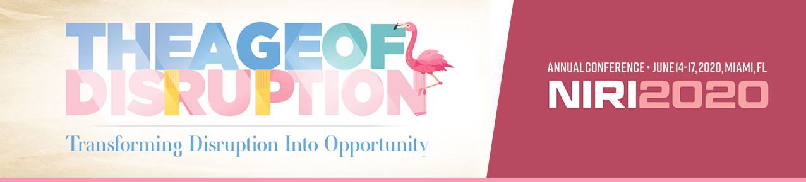

NIRI 2020 Annual Conference
Justification Letter to Supervisor

Below, you'll find a “justification letter” template — a letter to your supervisor explaining all of the benefits you'll receive from attending the 2020 NIRI Annual Conference.

The justification letter includes what you and your team can expect to gain from attending the conference. Feel free to customize this template to suit your needs.

Dear [Supervisor’s name],

I would like to attend the 2020 NIRI Annual Conference, June 14-17, 2020, in Miami, FL. This three-day conference, the world’s premiere gathering of investor relations professionals, is a unique opportunity for me to learn from industry experts and network with peers from the IR community.

Conference programming is tailored to ensure IR practitioners and others involved in accomplishing the goals of investor relations (such as CFOs, treasurers, corporate communicators, corporate secretaries, and corporate governance professionals) stay current on trends and key topics that are shaping the future of IR and the capital markets.

Over the course of the conference, I will participate in multiple education tracks, including IR strategy & planning; business insights & capital markets; marketing & stakeholder communications; corporate governance & ESG; and financial reporting & regulatory compliance. The conference offers me the opportunity to hear from leaders in the profession and other industry experts [and earn professional development units/CPE credits to maintain my IRC/CPA credential].

After reviewing the conference program, I have identified a number of educational sessions which are specifically relevant and of interest:

[Find the session names here]

These are only some of the sessions that I will attend. The full agenda is available at www.niri.org/conference.

There is additional value in the IR Showcase, the world’s largest exhibition of IR products and services. I will be able to view live demos, meet with dozens of exhibiting companies, and discover new products and services that will maximize the effectiveness of our IR activities.

I am requesting sponsorship for the registration fee, hotel, and travel expenses during the conference.
The full price conference fee is [insert appropriate registration rate] but can be reduced by $200 when registering before the advance registration deadline on March 31, 2020. Below is the breakdown of conference costs:

- Roundtrip Airfare: [insert your estimate]
- Transportation: [insert your estimate]
- Hotel: $269 + tax (based on availability). This rate expires on May 22, 2020.
- Meals: Included
- Conference fee: [insert the appropriate registration rate]
The total costs associated with attending this conference are: [total from above]

This opportunity for me to develop valuable contacts, discover new IR products and services, and further develop the skills and knowledge to perform my job function makes my attendance at the NIRI Annual Conference a wise investment for [company name].

Sincerely,

[your name]

